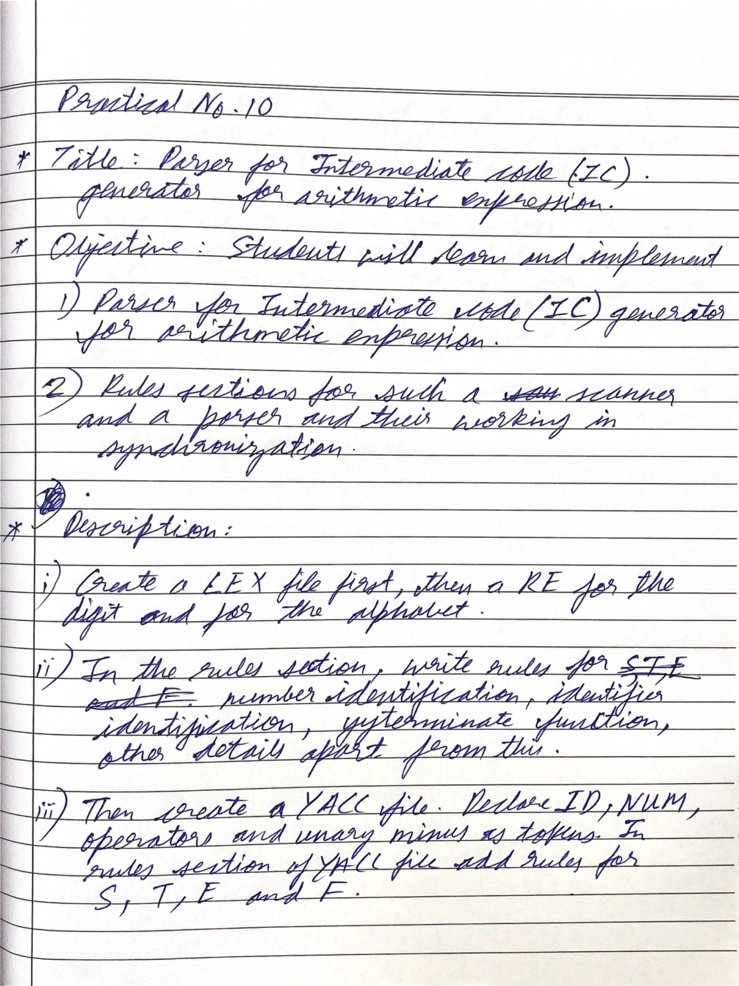

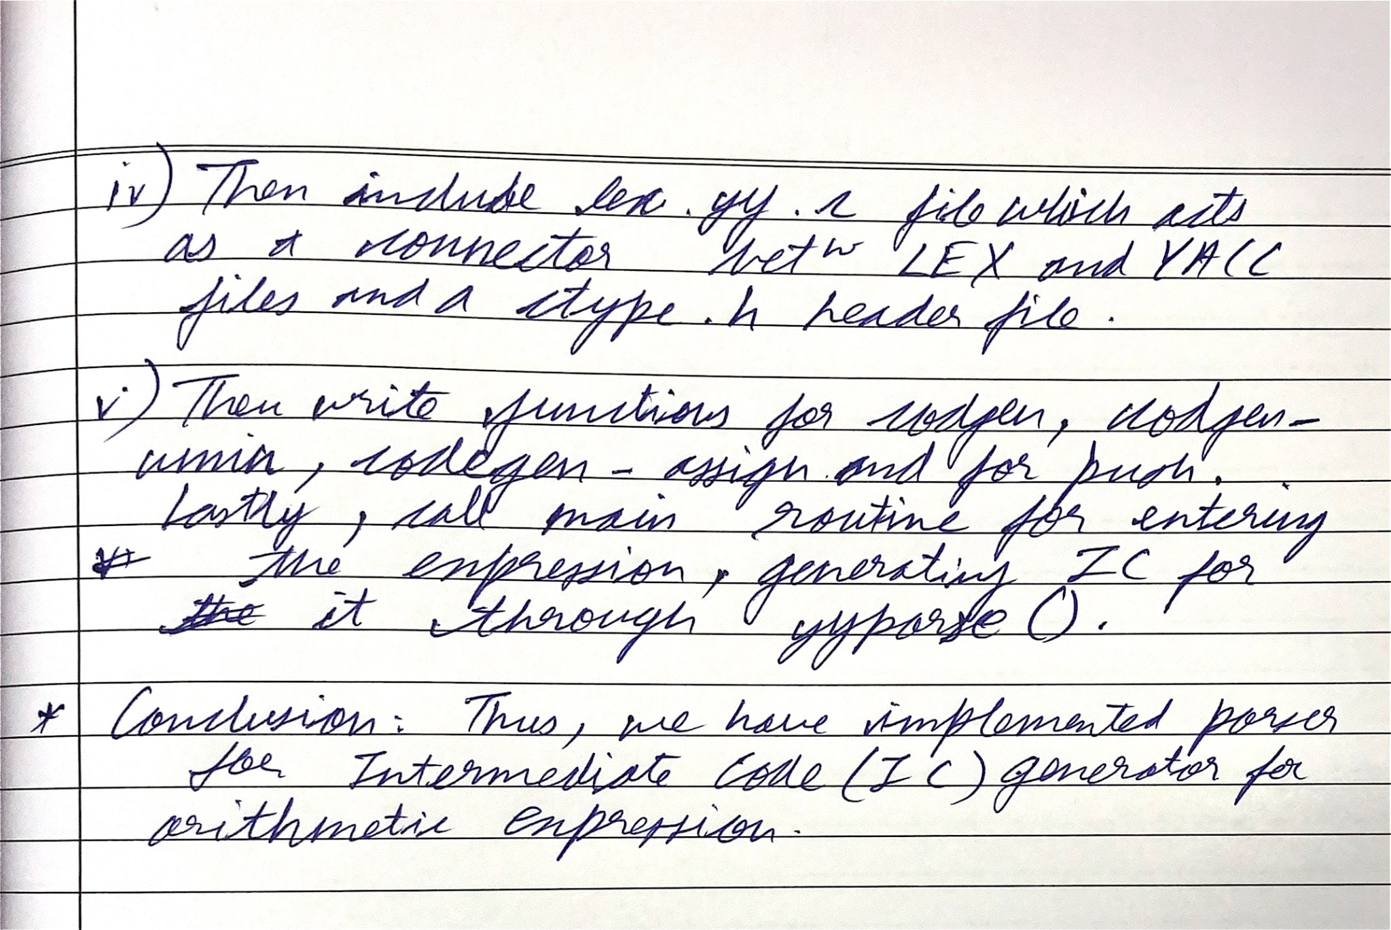

**Code for LEX:**

| ALPHA [A-Za-z] DIGIT [0-9]  %% " " ; {ALPHA}({ALPHA}|{DIGIT})* return ID; {DIGIT}+ {yylval = atoi(yytext); return NUM;} [\n\t] yyterminate(); . return yytext[0]; %% |
| --- |

**Code for YACC:**

| %{ #include <stdio.h> void yyerror(char*); int yylex(void); void codegen(); void codegen_assign(); void codegen_umin(); void printnum(int); void push(); %}  %token ID NUM %right '=' %left '+' '-' %left '*' '/' %left UMINUS %%  S : ID{push();} '='{push();} E{codegen_assign();}  ; E : E '+'{push();} T{codegen();}  | E '-'{push();} T{codegen();}  | T  ; T : T '*'{push();} F{codegen();}  | T '/'{push();} F{codegen();}  | F  ; F : '(' E ')'  | '-'{push();} F{codegen_umin();} %prec UMINUS  | ID{push();}  | NUM{push();}  ;  %%  #include "lex.yy.c" #include<ctype.h> #include<string.h> char st[100][25]; int top=0,ptr=0; int tint=0; int tintar[200];  int main() {  printf("Enter the expression : ");  yyparse();  return 0; }  void push() {  strcpy(st[++top],yytext);  ptr++; }  void codegen(){  printf("t%d = %s",tint,st[top-2]);  printnum(2);  printf(" %s %s",st[top-1],st[top]);  printnum(0);  printf("\n");  top-=2;ptr-=2;  strcpy(st[top],"t");  tintar[ptr]=tint;  tint++; }  void codegen_umin(){  printf("t%d = -%s\n",tint,st[top]);  printnum(0);  top--;ptr--;  strcpy(st[top],"t");  tintar[ptr]=tint;  tint++; }  void codegen_assign(){  printf("%s = ",st[top-2]);  printnum(2);  printf("%s",st[top]);  printnum(0);  printf("\n");  top-=2;ptr-=2; }  void printnum(int n){  if( strcmp(st[top-n],"t")==0)  {  printf("%d",tintar[ptr-n]);  } }  void yyerror(char* errorText){  printf("[ERROR] : %s",errorText); } |
| --- |

**Output:**

